Russian Journal of Plant Physiology, 2024, V. 71, № 1
SUPPLEMENTARY INFORMATION
USE OF BROMOCRESOL GREEN FOR THE SPECTROPHOTOMETRIC DETERMINATION OF ALKALOIDS IN THE EXAMPLE OF Ruta graveolans
A. I. Valieva^{а, *}, А. N. Akulov^{а}
ª Kazan Institute of Biochemistry and Biophysics of FRC Kazan Scientific Center of Russian Academy of Sciences, Kazan, Russian Federation
Corresponding author: Valieva A. I.
*e-mail: cell-culture@yandex.ru

Table 1. Optical density at λmax of the bromocresol-alkaloid ion pair at different residence times in the reaction mixture prior to extraction of the ion pair with chloroform.

Alkaloid  Residence times | Atropine sulfate | Papaverine hydrochloride | Nicotine
1 min | 0.199 ± 0.027 a | 0.197 ± 0.012 a | 0.187 ± 0.021 a
5 min | 0.208 ± 0.013 a | 0.206 ± 0.008 a | 0.192 ± 0.002 a
10 min | 0.216 ± 0.011 a | 0.197 ± 0.01 a | 0.194 ± 0.006 a
30 min | 0.216 ± 0.025 a | 0.173 ± 0.019 a | 0.172 ± 0.010 a
Note. Non-significant differences in mean values (P ≤ 0.05) are marked with the same letters.

Table 2. Optical characteristics and sensibility range of the assay
Parameters  Alkaloid | λ_{max}, nm | Linear dependence range, µg/mL | Equation | Correlation coefficient
Atropine sulfate | 417 | 2–10 | y = 0.0521x | R² = 0.9977
Papaverine hydrochloride | 418 | 3–10 | y = 0.0461x | R² = 0.9599
Nicotine | 414 | 4–10 | y = 0.0405x | R² = 0.9661

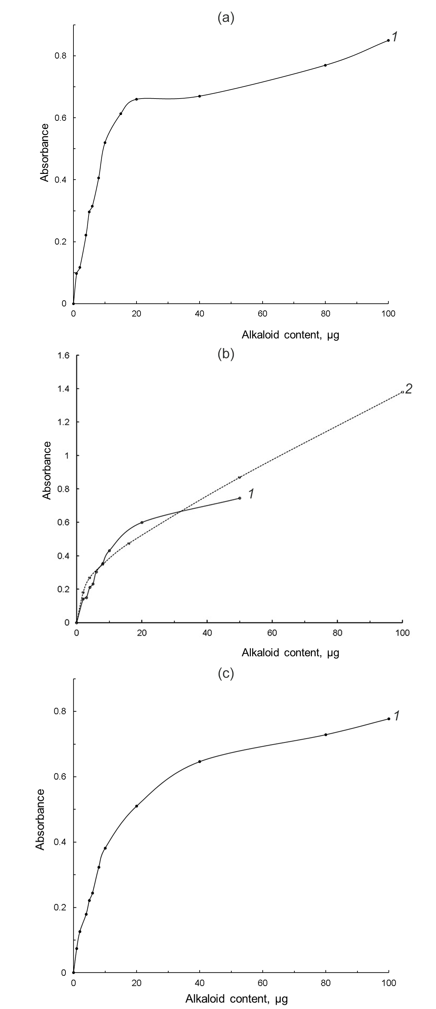

Figure S1. Calibration curves for atropine sulfate (a), papaverine hydrochloride (b), nicotine (c). For atropine sulfate and nicotine, 0.1 mM bromocresol green (BCG) was used in the reaction mixture, and 0.1 mM (1, solid line) and 0.5 mM (2, dashed line) BCG was used for papaverine hydrochloride.

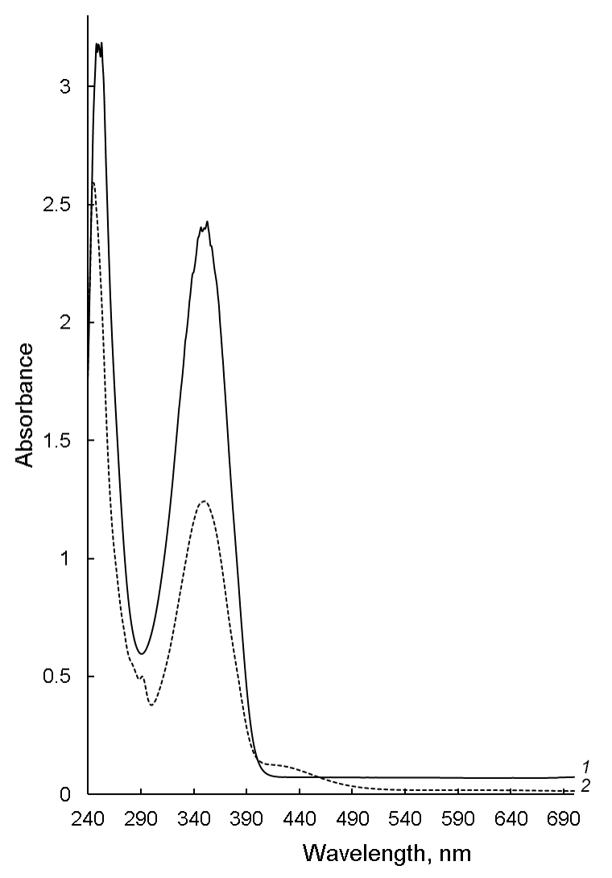
Figure S2. Absorption spectra of colchicine dissolved in chloroform (1, solid line) and of mixture of bromocresol green and colchicine (2, dashed line).

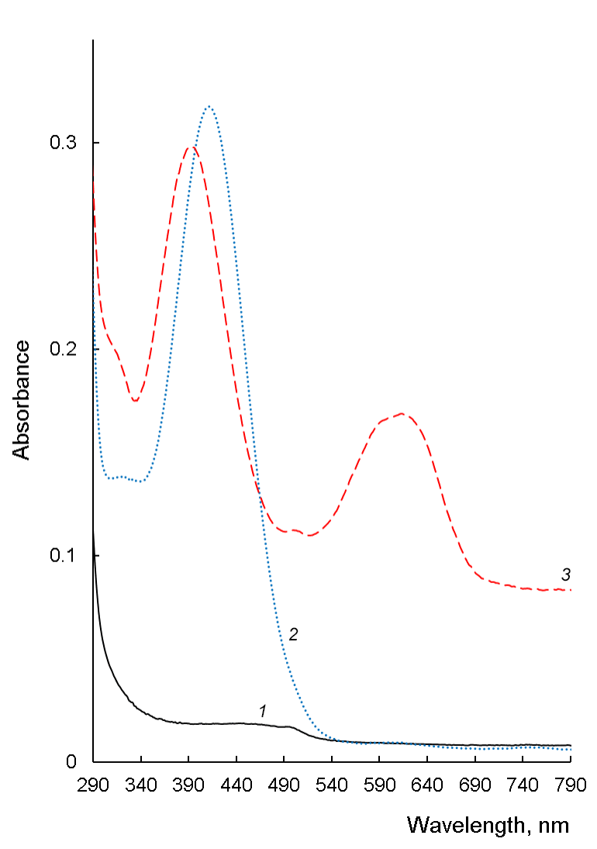
Figure S3. Absorption spectra of nicotine dissolved in chloroform (1, black solid line) and bromocresol green-nicotine ion pair before alkalinization (2, blue dotted line) and after alkalinization (3, red dashed line).

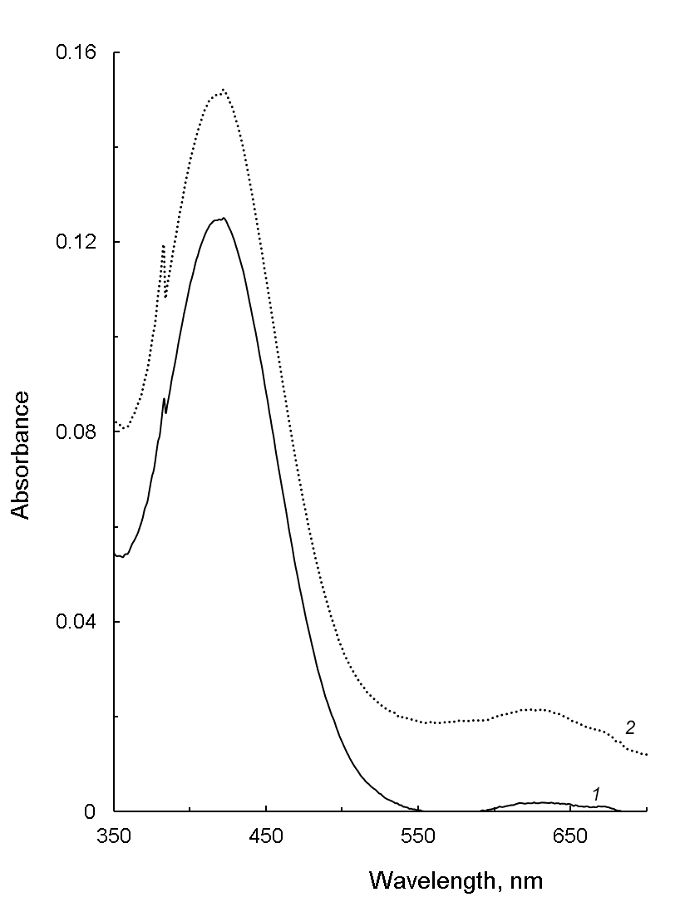
Figure S4. Absorption spectra of blank solutions prepared with different concentrations of bromocresol green: 10⁻⁴ M (solid line, 1) and 5∙10⁻⁴ M (dotted line, 2).

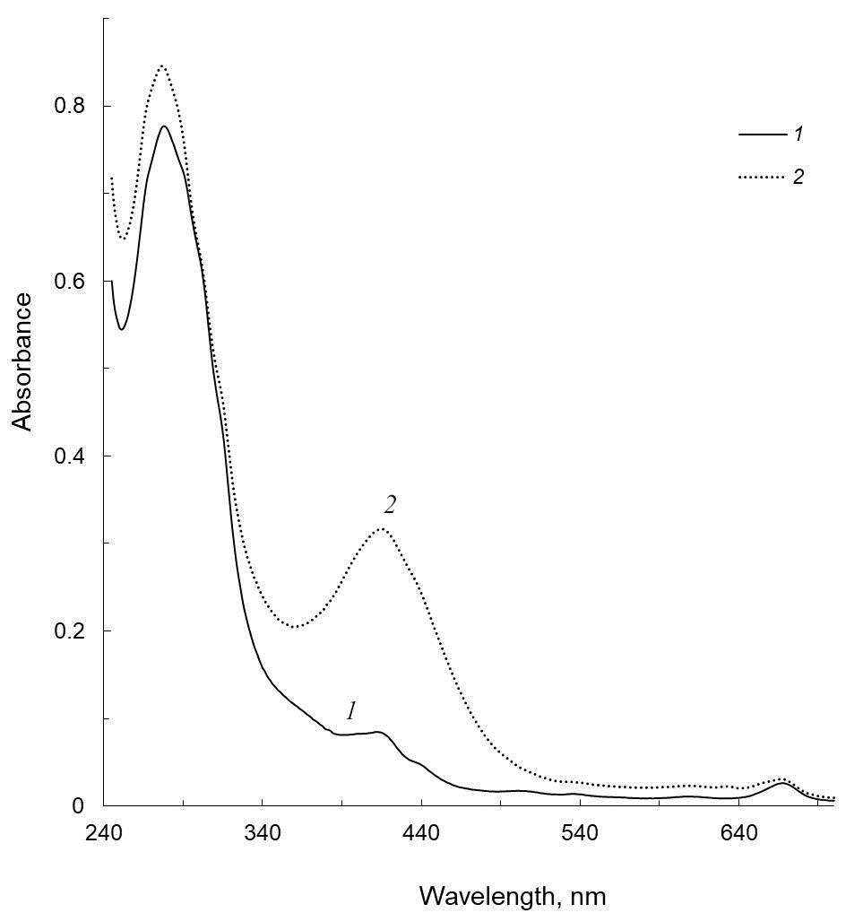
Figure S5. Absorption spectra of a sample of pharmacy medicine “Herba Ruta graveolens” measured before (solid line, 1) and after (dashed line, 2) addition of bromocresol green.

